| Experiment No. 1 |
| --- |
| Analyze the Boston Housing dataset and Apply appropriate  Regression Technique |
| Date of Performance: 16/7/2024 |
| Date of Submission: 23/7/2024 |

**Aim:** Analyze the Boston Housing dataset and Apply appropriate Regression Technique.

**Objective:** Ablility to perform various feature engineering tasks, apply linear regression on the given dataset and minimise the error.

# Theory:

Linear Regression is a machine learning algorithm based on supervised learning. It performs a regression task. Regression models a target prediction value based on independent variables. It is mostly used for finding out the relationship between variables and forecasting. Different regression models differ based on – the kind of relationship between dependent and independent variables they are considering, and the number of independent variables getting used.

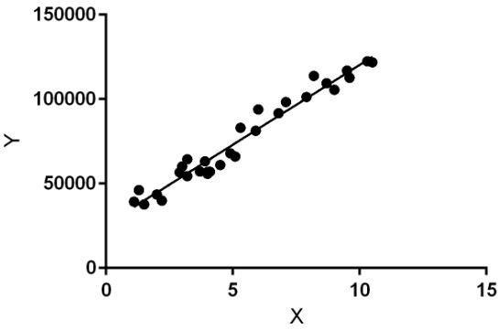

Linear regression performs the task to predict a dependent variable value (y) based on a given independent variable (x). So, this regression technique finds out a linear relationship between x (input) and y(output). Hence, the name is Linear Regression.

In the figure above, X (input) is the work experience and Y (output) is the salary of a person. The regression line is the best fit line for our model.

# Dataset:

The Boston Housing Dataset

The Boston Housing Dataset is a derived from information collected by the U.S. Census Service concerning housing in the area of Boston MA. The following describes the dataset columns:

CRIM - per capita crime rate by town

ZN - proportion of residential land zoned for lots over 25,000 sq.ft. INDUS - proportion of non-retail business acres per town.

CHAS - Charles River dummy variable (1 if tract bounds river; 0 otherwise) NOX - nitric oxides concentration (parts per 10 million)

RM - average number of rooms per dwelling

AGE - proportion of owner-occupied units built prior to 1940 DIS - weighted distances to five Boston employment centres RAD - index of accessibility to radial highways

TAX - full-value property-tax rate per $10,000 PTRATIO - pupil-teacher ratio by town

B - 1000(Bk - 0.63)^2 where Bk is the proportion of blacks by town LSTAT - % lower status of the population

MEDV - Median value of owner-occupied homes in $1000's

# CODE & OUTPUT:

import pandas as pd import numpy as np

file_path = 'BostonHousing.csv' *# Update this if your file path is differ ent*

data = pd.read_csv(file_path) print(data.head())

*# Display information about the dataset*

print(data.info())

*# Check for missing values*

print(data.isnull().sum())

| zn | indus | chas | nox | rm | age | dis | rad | tax | ptrat |
| --- | --- | --- | --- | --- | --- | --- | --- | --- | --- |
| 18.0 | 2.31 | 0 | 0.538 | 6.575 | 65.2 | 4.0900 | 1 | 296 | 15 |
| 0.0 | 7.07 | 0 | 0.469 | 6.421 | 78.9 | 4.9671 | 2 | 242 | 17 |
| 0.0 | 7.07 | 0 | 0.469 | 7.185 | 61.1 | 4.9671 | 2 | 242 | 17 |
| 0.0 | 2.18 | 0 | 0.458 | 6.998 | 45.8 | 6.0622 | 3 | 222 | 18 |
| 0.0 | 2.18 | 0 | 0.458 | 7.147 | 54.2 | 6.0622 | 3 | 222 | 18 |

crim

io \

0 0.00632

.3

1 0.02731

.8

2 0.02729

.8

3 0.03237

.7

4 0.06905

| .7 |  | | |
| --- | --- | --- | --- |
|  | b | lstat | medv |
| 0 | 396.90 | 4.98 | 24.0 |
| 1 | 396.90 | 9.14 | 21.6 |
| 2 | 392.83 | 4.03 | 34.7 |
| 3 | 394.63 | 2.94 | 33.4 |
| 4 | 396.90 | 5.33 | 36.2 |

<class 'pandas.core.frame.DataFrame'> RangeIndex: 506 entries, 0 to 505 Data columns (total 14 columns):

# Column Non-Null Count Dtype

| 0 |  | crim | 506 | non-null |  | float64 |
| --- | --- | --- | --- | --- | --- | --- |
| 1 |  | zn | 506 | non-null |  | float64 |
| 2 |  | indus | 506 | non-null |  | float64 |
| 3 |  | chas | 506 | non-null |  | int64 |
| 4 |  | nox | 506 | non-null |  | float64 |
| 5 |  | rm | 501 | non-null |  | float64 |
| 6 |  | age | 506 | non-null |  | float64 |
| 7 |  | dis | 506 | non-null |  | float64 |
| 8 |  | rad | 506 | non-null |  | int64 |
| 9 |  | tax | 506 | non-null |  | int64 |
| 10 |  | ptratio | 506 | non-null |  | float64 |
| 11 |  | b | 506 | non-null |  | float64 |
| 12 |  | lstat | 506 | non-null |  | float64 |
| 13 |  | medv | 506 | non-null |  | float64 |

dtypes: float64(11), int64(3)

| memory | usage: 55.5 KB |
| --- | --- |
| None |  |
| crim | 0 |
| zn | 0 |
| indus | 0 |
| chas | 0 |
| nox | 0 |
| rm | 5 |
| age | 0 |
| dis | 0 |
| rad | 0 |
| tax | 0 |

| ptratio | 0 |
| --- | --- |
| b | 0 |
| lstat | 0 |
| medv | 0 |
| dtype: | int64 |
| data = | data.dropna() |

*# Initial linear regression with all parameters*

X_all = data.drop(columns=['medv']) y_all = data['medv']

import matplotlib.pyplot as plt import seaborn as sns

from sklearn.model_selection import train_test_split from sklearn.linear_model import LinearRegression

from sklearn.metrics import mean_squared_error, r2_score

X_train_all, X_test_all, y_train_all, y_test_all = train_test_split(X_all, y_all, test_size=0.2, random_state=42)

*# Initialize the Linear Regression model*

model_all = LinearRegression()

*# Train the model*

model_all.fit(X_train_all, y_train_all) LinearRegression()

y_pred_all = model_all.predict(X_test_all)

mse_all = mean_squared_error(y_test_all, y_pred_all) rmse_all = np.sqrt(mse_all)

r2_all = r2_score(y_test_all, y_pred_all)

print(f"All Parameters - Mean Squared Error: {mse_all}") print(f"All Parameters - Root Mean Squared Error: {rmse_all}") print(f"All Parameters - R-squared: {r2_all}")

All Parameters - Mean Squared Error: 20.687720473048476 All Parameters - Root Mean Squared Error: 4.548375586189917 All Parameters - R-squared: 0.7200277678580317

*# Plotting actual vs predicted values for all parameters*

plt.figure(figsize=(10, 6))

plt.scatter(y_test_all, y_pred_all, edgecolor='k', alpha=0.7) plt.plot([y_test_all.min(), y_test_all.max()], [y_test_all.min(), y_test_a ll.max()], 'r--', lw=3)

plt.xlabel('Actual') plt.ylabel('Predicted')

plt.title('All Parameters - Actual vs Predicted Values') plt.show()

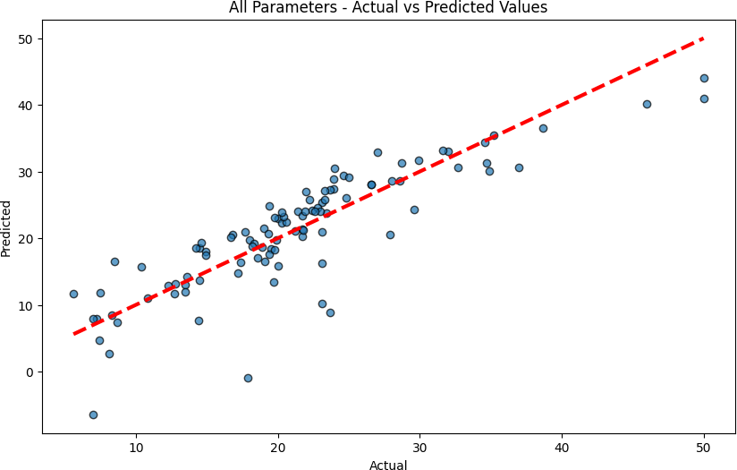

*# Draw a heatmap of correlations* plt.figure(figsize=(12, 10)) corr_matrix = data.corr()

sns.heatmap(corr_matrix, annot=True, cmap='coolwarm') plt.title('Correlation Heatmap')

plt.show()

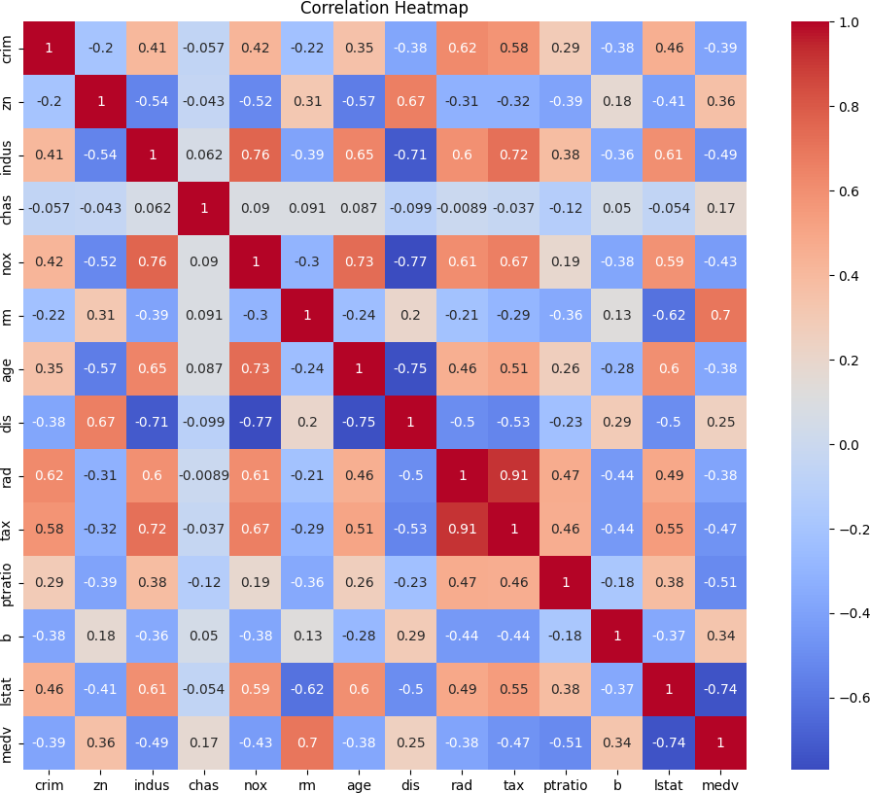

relevant_features = corr_matrix.index[abs(corr_matrix["medv"]) > 0.5].toli st()

relevant_features.remove('medv')

print("Selected relevant features:", relevant_features) Selected relevant features: ['rm', 'ptratio', 'lstat']

*# Linear regression with selected parameters* X_relevant = data[relevant_features] y_relevant = data['medv']

*# Split the data into training and testing sets*

X_train_rel, X_test_rel, y_train_rel, y_test_rel = train_test_split(X_rele vant, y_relevant, test_size=0.2, random_state=42)

*# Initialize the Linear Regression model*

model_rel = LinearRegression()

*# Train the model*

model_rel.fit(X_train_rel, y_train_rel)

LinearRegression()

y_pred_rel = model_rel.predict(X_test_rel)

*# Evaluate the model*

mse_rel = mean_squared_error(y_test_rel, y_pred_rel) rmse_rel = np.sqrt(mse_rel)

r2_rel = r2_score(y_test_rel, y_pred_rel)

print(f"Selected Parameters - Mean Squared Error: {mse_rel}") print(f"Selected Parameters - Root Mean Squared Error: {rmse_rel}") print(f"Selected Parameters - R-squared: {r2_rel}")

Selected Parameters - Mean Squared Error: 24.601921143326106 Selected Parameters - Root Mean Squared Error: 4.960032373213516 Selected Parameters - R-squared: 0.6670558853281565

*# Plotting actual vs predicted values for selected parameters*

plt.figure(figsize=(10, 6))

plt.scatter(y_test_rel, y_pred_rel, edgecolor='k', alpha=0.7) plt.plot([y_test_rel.min(), y_test_rel.max()], [y_test_rel.min(), y_test_r el.max()], 'r--', lw=3)

plt.xlabel('Actual') plt.ylabel('Predicted')

plt.title('Selected Parameters - Actual vs Predicted Values') plt.show()

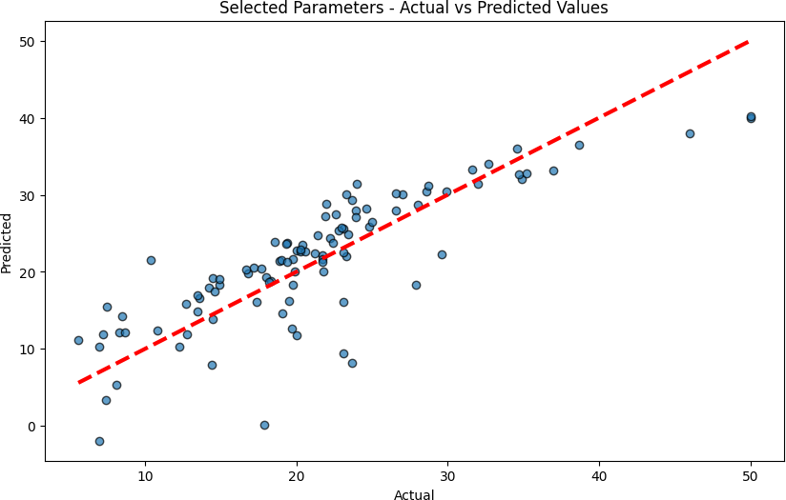

*# Compare results*

print("\nComparison:")

print(f"All Parameters - RMSE: {rmse_all}, R-squared: {r2_all}") print(f"Selected Parameters - RMSE: {rmse_rel}, R-squared: {r2_rel}")

Comparison:

All Parameters - RMSE: 4.548375586189917, R-squared: 0.7200277678580317

Selected Parameters - RMSE: 4.960032373213516, R-squared: 0.66705588532815 65

# Conclusion:

The Mean Squared Error (MSE) calculated for the model using all features is lower, suggesting that this model better captures the variability in the housing prices. This could be due to the inclusion of additional information, even if some features contribute noise. Conversely, the higher MSE for the model with selected features indicates that important information might have been lost by excluding certain features, leading to less accurate predictions. This highlights the complexity of feature selection, where excluding less correlated features doesn't always result in improved model performance.